Template and Instructions for the Preparation of a Conference Proceedings Paper
A. N. Author¹, A. Coauthor¹ and A. Thirdauthor²
¹Institute of ABC, University of Somewhere ...
² Institute of XYZ, University of Somewhere Else ...
Title, Author and Abstract
For the title of the paper use style ‘Title’: 14 pt Times New Roman bold; start at top of page, flush left, do not break words, initial capitals for main words, 23 pt space between title and author.
Use styles ‘Author’ and ‘Author address’: 11 pt Times New Roman, flush left, one line space between author(s) and address(es).

Abstract. A short abstract (one page only summary) of your contribution may be inserted here. Use short, direct sentences. It should be as concise as possible. It should be complete, self-explanatory and should not require reference to the paper itself. The abstract should be informative, giving the scope and emphasizing the main conclusions, results, or significance of the work described. Use style ‘Abstract’: 10 pt Times New Roman, justified, flush left, two line space between Abstract and Author address. Make the word Abstract bold followed by a point.

Illustrations: Please avoid illustrations in abstract. Use it only if absolutely necessary
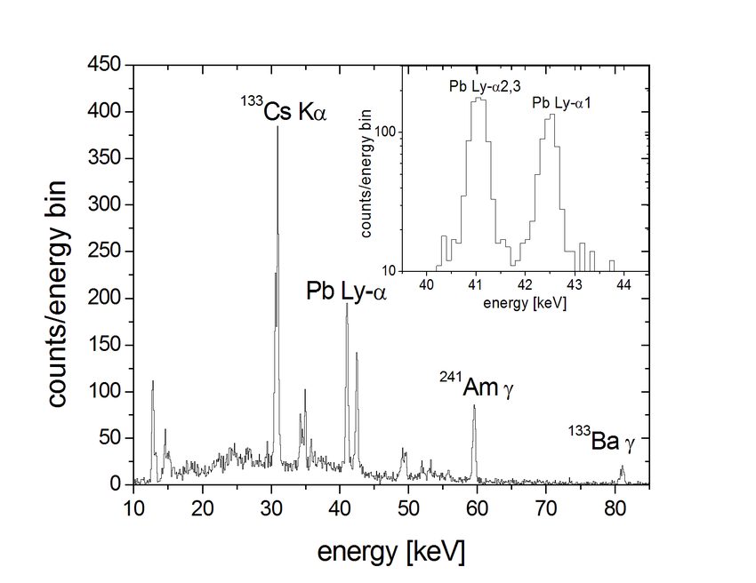
The size of figure should be commensurate with the amount and value of the information the figure has to convey.
Fig. 1. Use ‘Figure caption’ style for figure caption: Times New Roman, 10 pt, flush left.

Tables: No table should be there in abstract.

3.5 References
10 pt Times New Roman, justified, indent turnover lines 0.6 cm. See the example below.

References
1. Whitham, G. B.: Linear and nonlinear waves, Academic Press, 1974
2. Case, M.: 'Impulse compression using soliton effects in a monolithic GaAs circuit', App. Phys. Lett., 58, 173-175, 1993

